**High Impact Skills Development Program**

**in Artificial Intelligence, Data Science, and Blockchain**

**Module 3: Data Visualization**

Lab 2: Getting Started with Tableau

Instructor: Dr. Arham Muslim

Assistant Professor, SEECS, NUST

# Objective:

In this lab, you will learn the basics of Tableau, including setting up an account, connecting to a dataset, and creating basic visualizations.

# Materials Needed:

* Tableau Online

# Datasets:

* Detailed Sales Dataset

# Lab Work:

## Task 1: Setting Up Tableau

* Create a Tableau Public Profile and Sign In
  + Visit the Tableau Public (https://public.tableau.com) website.
  + Create an account by providing your email address and a password.
  + Once your account is created, sign in to access the Tableau Public interface.
* Download and Install Tableau Public App (optional)
  + If you want to try out Tableau Public on your PC, you can download and install it from the Tableau Public website (<https://public.tableau.com/en-us/s/download>).
  + Follow the installation instructions specific to your operating system.
  + Open the Tableau Public App and sign in with your Tableau Public credentials.
* Explore the Tableau Interface
  + Familiarize yourself with the Tableau interface. A sample screen is provided below on which different areas are marked.
  + Identify key areas such as the Data pane, the Worksheet Navigation area, the Columns and Rows shelves, and the Show Me pane for visualization recommendation.
  + This exploration will help you navigate and use Tableau efficiently.

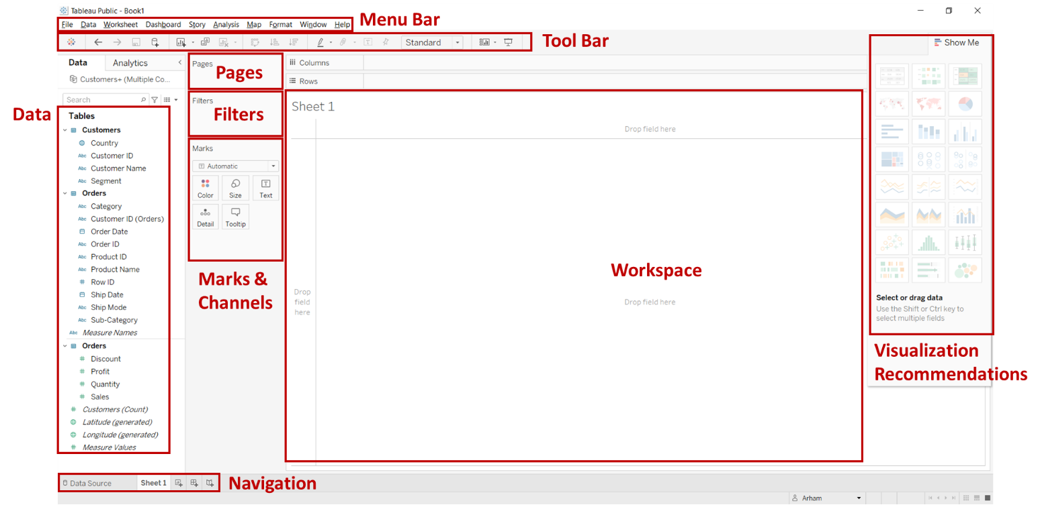

## Task 2: Preparing and Connecting to Data

* Prepare Your Dataset
  + Choose a dataset to work with, such as a CSV or Excel file.
  + Ensure the dataset is well-structured with clear headers and no missing values.
  + For this task, you will be using the Detailed Sales Dataset (Detailed-Sales.csv).
* Connect to Your Dataset in Tableau
  + Open Tableau and click on "Connect".
  + Locate and select your dataset (Detailed-Sales.csv) to import it into Tableau.
* Explore the Data Source Tab
  + After connecting your dataset, navigate to the Data Source tab in Tableau.
  + Examine the fields (columns) and data types.
  + This step is crucial for understanding the structure and content of your dataset before creating visualizations.

## Task 3: Creating Basic Visualizations

* Create a Bar Chart for Sales by Product Category
  + Drag the "Productline" field to the Columns shelf and the "Sales" field to the Rows shelf. Tableau will automatically create a bar chart displaying sales for each product category.
* Customize Colors, Labels, and Titles
  + Enhance your bar chart by adding color to distinguish different statuses.
  + Drag the "Status" field to the Color Mark.
  + Add labels to each bar by dragging the "Quantityordered" field to the Label Mark.
  + Finally, provide a title for your chart by double-clicking on the title area and entering a descriptive title.
* Create a Line Chart for Sales Over Time
  + Create a New Worksheet
  + Drag the "Orderdate" field to the Columns shelf and the "Sales" field to the Rows shelf.
  + Tableau will create a line chart showing sales trends over time.
  + Customize the x-axis to show the month-years.
  + Customize the line chart by adjusting the colors, labels, and adding a title.

## Task 4: Building a Simple Dashboard

* Combine Multiple Visualizations into a Dashboard
  + Click on the "New Dashboard" icon to create a new dashboard. Drag your previously created bar chart and line chart onto the dashboard workspace.
* Arrange Charts and Filters
  + Arrange the charts on the dashboard to create a cohesive and visually appealing layout.
  + Use the drag-and-drop functionality to position the charts.
  + Add filters by dragging fields to the Filters shelf to allow users to interact with the data.
* Add Titles and Descriptions to the Dashboard
  + Provide context for your dashboard by adding titles and descriptions.
  + Double-click on the title area to edit it, and use text boxes to add descriptions that explain what each visualization represents.

## Task 5: Saving and Sharing Work

* Publish the Workbook to Tableau Public
  + Click on "Server" and select "Tableau Public" followed by "Save to Tableau Public As."
  + Provide a name and description for your workbook, and then publish it to make it accessible online.

# Additional Resources for Self-Learning:

* [Get Started - Tableau](https://help.tableau.com/current/pro/desktop/en-us/gettingstarted_overview.htm)
* [Tableau Tutorial for Beginners: Learn Basics in 3 Days](https://www.guru99.com/tableau-tutorial.html)
* [Creating Data Visualizations Using Tableau Desktop (Beginner)](https://mdl.library.utoronto.ca/technology/tutorials/creating-data-visualizations-using-tableau-desktop-beginner)
* [How-To Videos - Tableau Public](https://public.tableau.com/app/learn/how-to-videos)